

**Database Structures and Algorithms Lab**

**(18B15CS211)**

**PROJECT REPORT**

**HOSTEL MANAGEMENT SYSTEM**

**ODD SEMESTER 2022**

*(B.Tech - 3rd Semester - IT)*

***GROUP MEMBERS:***

* *ARYAN GUPTA (21104031)*
* *PRITPAL SINGH (21104023)*
* *SAMARPIT KANDHARI (*21104067)
* *DWEEP (21104003)*

**CANDIDATE DECLARATION**

I hereby declare that the project report entitled "**HOSTEL MANAGEMENT SYSTEM**" which is being submitted in partial fulfilment of the requirement for the completion of Data Structures and Algorithms Lab (2 credits), as a part of Bachelors of Technology Degree, Jaypee Institute of Information Technology (Deemed to be University), NOIDA, is an authentic record of my work carried out during the odd semester 2022. The work under this project has been carried out under the supervision and guidance of **Dr. Apeksha Aggarwal**.

ARYAN GUPTA (21104031)

PRITPAL SINGH (21104023)

SAMARPIT KANDHARI (21104067)

DWEEP (21104003)

**Date:** December 1st, 2022

This is to certify that above statement made by the candidate is correct to the best of our knowledge.

**PROBLEM STATEMENT AND OBJECTIVES**

The students' hostel is the main place for college students' daily life, so the students' hostel management is an important part of college management. As the growth of the college recruitment of students increases, the growing number of students, make the student hostel management faced with multiple complex situations. The problem of how to decipher, becomes the focus of the college logistics department leadership focuses on. In order to adapt to the needs of the development of the college, and further improve the efficiency of college logistics work, the college logistics department needs to adapt the student hostel management software system, in order to give full play to the advantages of modern information technology and Internet, realize the artificial management to change the way of computer management, increasing the working efficiency of the management team.

**ABSTRACT**

This Hostel Management System is designed to ease the workflow in universities and colleges so as to make the hostel allocation fast and less complex. The system users have 2 types of roles which are the Administrator(Warden) and Students. Both users must log in with their apt login credentials to gain access to the features and functionalities of the application. The Administrator has the privilege to allocate and manage the rooms to the students applying as per their requests. While Students on the other hand, as logically obvious, can register and obviously raise a request for the allotment of the room. This Hostel Management System allows the admin to manage the list of hostel rooms, and student requests. The admin must populate first the list of rooms in the system, and students have to raise a request. Once that been done, the proctor can simply use the assign_room feature to assign the rooms on the first-come-first-serve bases. The system was developed with user-friendly features and. It can help the college management to efficiently and effectively manage the collections and account records.

**CODE SNIPPET**

#include <iostream>

using namespace std;

struct Node{

int roomNo;

string studentID;

string firstName;

string lastName;

int phoneNumber;

char block;

Node *previous;

Node *next;

} *head=NULL, *tail=NULL;

struct RoomKey {

int roomNo;

char block;

int floor;

RoomKey *next;

} *top=NULL;

struct Request {

string studentID;

string firstName;

string lastName;

string email;

int phoneNumber;

Request *next;

} *front=NULL, *rear=NULL, *temp;

struct Room{

string studentID;

int roomNo;

char block;

Room *next;

Room *previous;

} *head1=NULL, *tail1=NULL;

void admin_menu();

void student_menu();

void wardenLogin();

void pushRoom(int, int, char);

void displayRooms();

void requestroom();

void displayRequests();

void assignRoom();

void checkAssigment();

void viewAssignedRooms();

void checkIn();

void viewCheckedIn();

int main() {

cout<<endl << endl;

cout<<"\t||=================================================================||"<<endl;

cout<<"\t|| ||"<<endl;

cout<<"\t|| ||"<<endl;

cout<<"\t|| JIIT HOSTEL MANAGEMENT SYSTEM ||"<<endl;

cout<<"\t|| ||"<<endl;

cout<<"\t|| ||"<<endl;

cout<<"\t||=================================================================||"<<endl;

cout<<endl;

cout<<"Welcome to JIIT Hostel Management System! "<<endl;

int role;

cout<<endl;

cout<<"Press 1 for Warden 2 for Student"<<endl;

cin>>role;

if (role==1) {

wardenLogin();

}

else if(role==2) {

student_menu();

}

else {

cout<<"Invalid Choice."<<endl;

}

return 0;

}

void admin_menu()

{

int choice, sure, roomNo, flr;

char block;

do {

cout<<endl;

cout<<endl<<endl<<"\t\t ------ ADMIN MENU ------"<<endl<<endl<<endl;

cout<<"\t\t\t 1. Add to available rooms list."<<endl;

cout<<"\t\t\t 2. View all available rooms."<<endl;

cout<<"\t\t\t 3. View all assigned rooms"<<endl;

cout<<"\t\t\t 4. View all room request."<<endl;

cout<<"\t\t\t 5. Assign room to student."<<endl;

cout<<"\t\t\t 6. Check In studentd. "<<endl;

cout<<"\t\t\t 7. View list of students who have checked in."<<endl;

cout<<"\t\t\t 8.Exit"<<endl;

cout<<"\t\t\t 9.Log Out"<<endl;

cin>>choice;

switch (choice) {

case 1:

cout << "\n\n\t\t ------ ADD ROOM KEY ------\n\n\n";

cout<<"Enter Room Number: ";

cin>>roomNo;

cout<<"Enter Room Floor: ";

cin>>flr;

cout<<"Enter Room Block: ";

cin>>block;

pushRoom(roomNo, flr, block);

break;

case 2:

cout<<"\n\n\t\t ------ VIEW AVAILABLE ROOMS ------\n\n\n";

displayRooms();

break;

case 3:

cout << "\n\n\t\t ------ ASSIGNED ROOMS ------\n\n\n";

viewAssignedRooms();

break;

case 4:

cout << "\n\n\t\t -------- ROOM REQUESTS -------\n\n\n";

displayRequests();

break;

case 5:

cout << "\n\n\t\t -------- ASSIGN ROOM -------\n\n\n";

assignRoom();

break;

case 6:

cout << "\n\n\t\t ------- ADD STUDENT CHECK-IN -------\n\n\n";

checkIn();

break;

case 7:

cout << "\n\n\t\t -------- VIEW STUDENTS THAT CHECKED IN -------\n\n\n";

viewCheckedIn();

break;

case 8:

cout<<"Are you sure you want to exit?\n";

cout<<"1. Yes \n2. No\n";

cin>>sure;

if(sure==1) {

cout << "\n\n\t\t ------ EXIT ------\n\n\n";

exit(1);

}

else if(sure==2) {

admin_menu();

}

else {

cout<<"Invalid button";

}

break;

case 9:

main();

break;

default:

cout<<"Invalid option."<<endl;

}

}while (choice!=8);

}

void student_menu()

{

int choice;

int sure;

do {

cout<<endl;

cout <<endl<<endl<<"\t\t ------ STUDENT MENU ------"<<endl<<endl<<endl;

cout << "\t\t\t 1. Request a room." << endl;

cout << "\t\t\t 2. Room allotment status." << endl;

cout << "\t\t\t 3. Exit" << endl;

cout << "\t\t\t 4. Main Menu"<<endl<<endl;

cin>>choice;

switch (choice) {

case 1:

requestroom();

break;

case 2:

checkAssigment();

break;

case 3:

cout<<"Are you sure you want to exit?\n";

cout<<"1 Yes \n2 No\n";

cin>>sure;

if(sure==1) {

cout << "\n\n\t\t ------ EXIT ------\n\n\n";

cout << endl << endl;

exit(1);

}

else if(sure==2) {

main();

}

else {

cout<<"Invalid option.";

}

break;

case 4:

main();

break;

default:

cout<<"Invalid option.";

}

} while(choice!=3);

}

void wardenLogin(){

string user;

string pass;

cout<<"-------Admin Login-------\n";

cout<<"Enter your username: \n";

cin>>user;

cout<<"Enter your password: \n";

cin>>pass;

if(user=="warden" && pass=="pass") {

cout<<"Welcome ADMIN!\n";

admin_menu();

}

else{

cout<<"Username or password incorrect.\n";

main();

}

}

void pushRoom(int roomNo, int floor, char block){

RoomKey *newRoomKey= new RoomKey;

newRoomKey->roomNo= roomNo;

newRoomKey->floor= floor;

newRoomKey->block= block;

newRoomKey->next= top;

top=newRoomKey;

}

void displayRooms() {

RoomKey *ptr;

if(top==NULL) {

cout<<"There are no rooms available! \n";

}

else {

ptr=top;

cout<<"The available rooms are: \n";

cout<<"RoomNo\tFloor\tBlock\n";

while(ptr!= NULL) {

cout<< ptr->roomNo<<"\t"<<ptr->floor<< "\t"<<ptr->block<<endl;

ptr=ptr->next;

}

}

cout<<endl;

}

void requestroom() {

string fname, lname, gmail, sid;

int pNo;

cout<<"----------Request room----------\n";

cout<<"Please note you should be a student in JIIT to request for a room here, and you are required to bring proofs in order to receive your keys!"<<endl<<endl;

cout<<"Enter your first name: ";

cin>>fname;

cout<<"Enter your last name: ";

cin>>lname;

cout<<"Enter your student ID: ";

cin>>sid;

cout<<"Enter your email address: ";

cin>>gmail;

cout<<"Enter your phone number: ";

cin>>pNo;

if(rear==NULL) {

rear=new Request;

rear->next=NULL;

rear->firstName= fname;

rear->lastName= lname;

rear->studentID= sid;

rear->email= gmail;

rear->phoneNumber=pNo;

front=rear;

}

else {

temp=new Request;

rear->next=temp;

temp->firstName= fname;

temp->lastName= lname;

temp->studentID= sid;

temp->email= gmail;

temp->phoneNumber=pNo;

temp->next=NULL;

rear=temp;

}

}

void displayRequests() {

temp= front;

if((front==NULL) && (rear==NULL)){

cout<<"There are no current requests\n";

return;

}

cout<<"Requests are: \n";

cout<<"Name\t\tID\tEmail\t\tPhoneNo\n";

while(temp!=NULL) {

cout<<temp->firstName<<" "<<temp->lastName<<"\t"<<temp->studentID<<"\t"<<temp->email<<"\t"<<temp->phoneNumber<< " "<< endl;

temp=temp->next;

}

cout<<endl;

}

void assignRoom(){

temp=front;

if(top==NULL){

cout<<"No available rooms! \n";

return;

}

else {

if(front==NULL){

cout<<"There are no current requests\n";

return;

}

else if(temp->next!=NULL) {

Node *newNode= new Node;

temp=temp->next;

cout<<"Student "<<front->studentID<<" has been allocated to room number "<<top->roomNo<< " in block "<<top->block<<"."<<endl;

newNode->firstName=front->firstName;

newNode->lastName =front->lastName;

newNode->studentID= front->studentID;

newNode->phoneNumber=front->phoneNumber;

newNode->roomNo=top->roomNo;

newNode->block=top->block;

newNode->next=NULL;

if(head==NULL) {

newNode->next=NULL;

head=newNode;

tail=newNode;

}

else {

newNode->previous=tail;

tail->next=newNode;

tail=newNode;

}

top=top->next;

free(front);

front=temp;

}

else {

cout<<"Student "<<front->studentID<<" has been allocated to room number "<<top->roomNo<< " in block "<<top->block<<"."<<endl;

Node *newNode= new Node;

newNode->firstName=front->firstName;

newNode->lastName =front->lastName;

newNode->studentID= front->studentID;

newNode->phoneNumber=front->phoneNumber;

newNode->roomNo=top->roomNo;

newNode->block=top->block;

newNode->next=NULL;

if(head==NULL) {

newNode->next=NULL;

head=newNode;

tail=newNode;

}

else {

newNode->previous=tail;

tail->next=newNode;

tail=newNode;

}

top=top->next;

free(front);

front=NULL;

rear=NULL;

}

}

}

void viewAssignedRooms() {

if(head==NULL) {

cout<<"There are no rooms assigned\n";

}

else {

Node *temp1=head;

cout<<"RoomNo Block Student ID\tName\t\tPhone No\n";

while(temp1!=NULL) {

cout<<temp1->roomNo<<"\t"<<temp1->block<<"\t"<<temp1->studentID<<"\t"<<temp1->firstName<<" "<<temp1->lastName<<"\t"<<temp1->phoneNumber<<"\n";

temp1=temp1->next;

}

}

}

void checkIn() {

string key;

int sure;

cout<<"Ennter the student Id of the student that has checked in: ";

cin>>key;

if(head==NULL) {

cout<<"Room Assignment list is empty";

}

else

{

Node *temp1=head;

while(temp1->studentID!=key) {

if(temp1->next==NULL) {

cout<<"Record not found\n!";

break;

}

temp1=temp1->next;

}

if(temp1->studentID==key) {

cout<<temp1->roomNo<<"\t"<<temp1->block<<"\t"<<temp1->studentID<<"\t"<<temp1->firstName<<" " <<temp1->lastName<<"\t"<<temp1->phoneNumber<<"\n";

cout<<"Are you sure this student has checked in? \n1. Yes 2. No\n";

cin>>sure;

if(sure==1) {

if(head->next==NULL) {

Room *newRoom= new Room;

newRoom->roomNo=temp1->roomNo;

newRoom->block=temp1->block;

newRoom->studentID=temp1->studentID;

newRoom->next=NULL;

if(head1==NULL) {

newRoom->next=NULL;

head1=newRoom;

tail1=newRoom;

}

else {

newRoom->previous=tail1;

tail1->next=newRoom;

tail1=newRoom;

}

head=NULL;

tail=NULL;

}

else {

if(temp1==head) {

Room *newRoom= new Room;

newRoom->roomNo=temp1->roomNo;

newRoom->block=temp1->block;

newRoom->studentID=temp1->studentID;

newRoom->next=NULL;

if(head1==NULL) {

newRoom->next=NULL;

head1=newRoom;

tail1=newRoom;

}

else {

newRoom->previous=tail1;

tail1->next=newRoom;

tail1=newRoom;

}

head=head->next;

(temp1->next)->previous=NULL;

}

else if(temp1==tail) {

Room *newRoom= new Room;

newRoom->roomNo=temp1->roomNo;

newRoom->block=temp1->block;

newRoom->studentID=temp1->studentID;

newRoom->next=NULL;

if(head1==NULL) {

newRoom->next=NULL;

head1=newRoom;

tail1=newRoom;

}

else {

newRoom->previous=tail1;

tail1->next=newRoom;

tail1=newRoom;

}

tail=tail->previous;

(temp1->previous)->next=NULL;

}

else {

Room *newRoom= new Room;

newRoom->roomNo=temp1->roomNo;

newRoom->block=temp1->block;

newRoom->studentID=temp1->studentID;

newRoom->next=NULL;

if(head1==NULL) {

newRoom->next=NULL;

head1=newRoom;

tail1=newRoom;

}

else {

newRoom->previous=tail1;

tail1->next=newRoom;

tail1=newRoom;

}

(temp1->previous)->next=temp1->next;

(temp1->next)->previous=temp1->previous;

}

}

}

else {

cout<<"Entry has not been deleted";

}

cout<<" Student: "<<temp1->firstName<<" "<<temp1->lastName<<" [ "<<temp1->studentID<<" ] has received key for Room "<<temp1->roomNo<<" in Block "<<temp1->block<<" .\n";

}

}

}

void viewCheckedIn() {

if(head1==NULL) {

cout<<"There are no rooms assigned\n";

}

else {

Room *temp2=head1;

cout<<"RoomNo\tBlock\tStudent ID\n";

while(temp2!=NULL) {

cout<<temp2->roomNo<<"\t"<<temp2->block<<"\t"<<temp2->studentID<<"\n";

temp2=temp2->next;

}

}

}

void checkAssigment(){

int hasRoom;

cout<<"Have you requested for a room in JIIT Hostel Management System ? \n";

cout<< "1. Yes 2. No\n";

cin>>hasRoom;

if(hasRoom==1) {

string key;

cout<<"Enter your student ID: ";

cin>>key;

if(head==NULL) {

cout<<"You have not been assigned a room yet";

}

else {

Node *temp1=head;

while(temp1->studentID!=key) {

if(temp1->next==NULL) {

cout<<"You have not been assigned a room yet";

break;

}

temp1=temp1->next;

}

if(temp1->studentID==key) {

cout<<"Dear Student: "<<temp1->firstName<<" "<<temp1->lastName<<"\n";

cout<<"You have been allocated to Room number: "<< temp1->roomNo <<" in Block: "<< temp1->block<<". \n";

cout<<"Please come to the "<<temp1->block<<" the roomitory office to take your keys, and ID within 2 business days\n";

cout<<endl<<endl;

cout<<"Please note that you are required to bring your student ID, national ID, course registration slip, clearance letters(if you've had room rooms before), and letter from your sub-city (if you are an Addis Ababa resident) to receive your room\n"<<endl;

cout << "\t........................................................................................................" << endl << endl;

cout << "\t Thank you for using JIIT Hostel management system " << endl << endl;

cout << "\t........................................................................................................" << endl << endl;

}

}

}

else if (hasRoom==2) {

cout<<"You are supposed to first request for a room in order to check your assignment. Please request and try again later\n";

}

else {

cout<<"Invalid choice.\n";

}

}

**SNAPSHOTS**

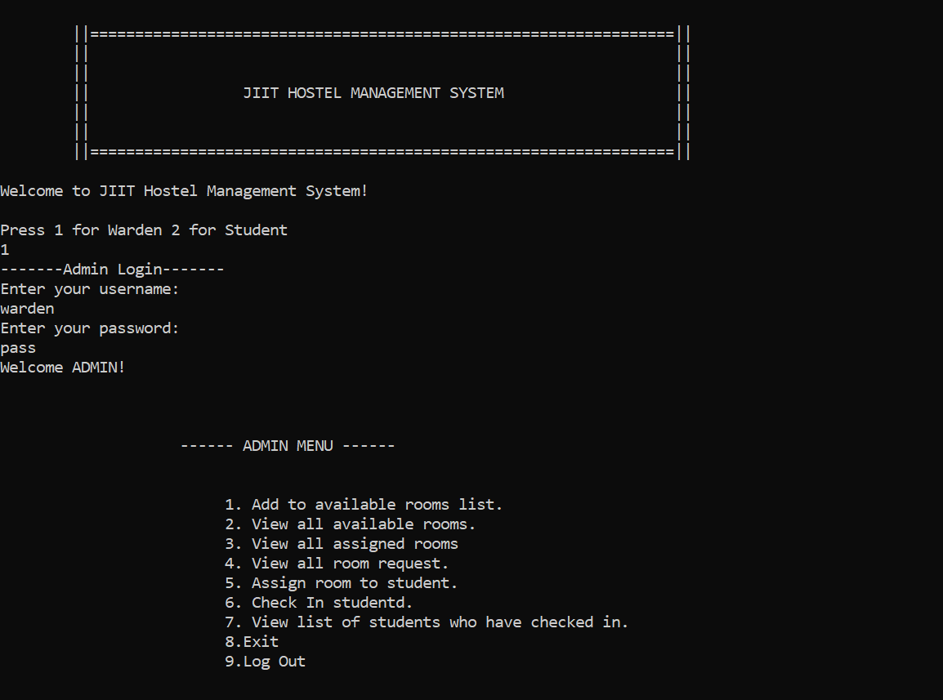

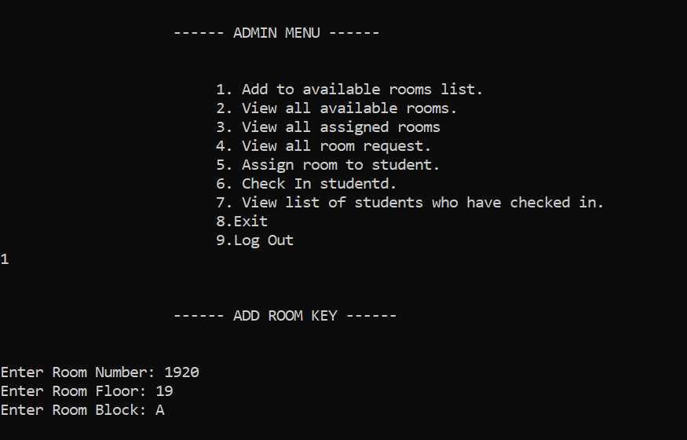 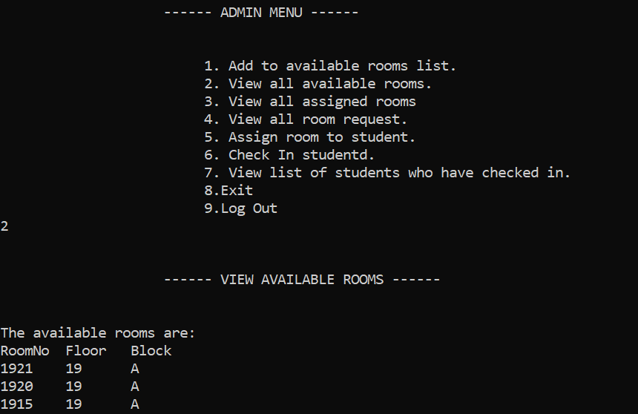 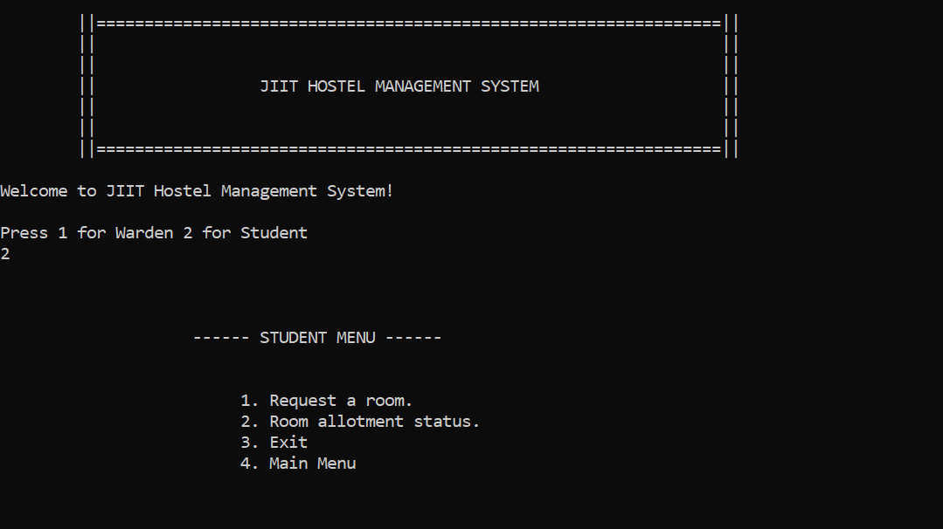 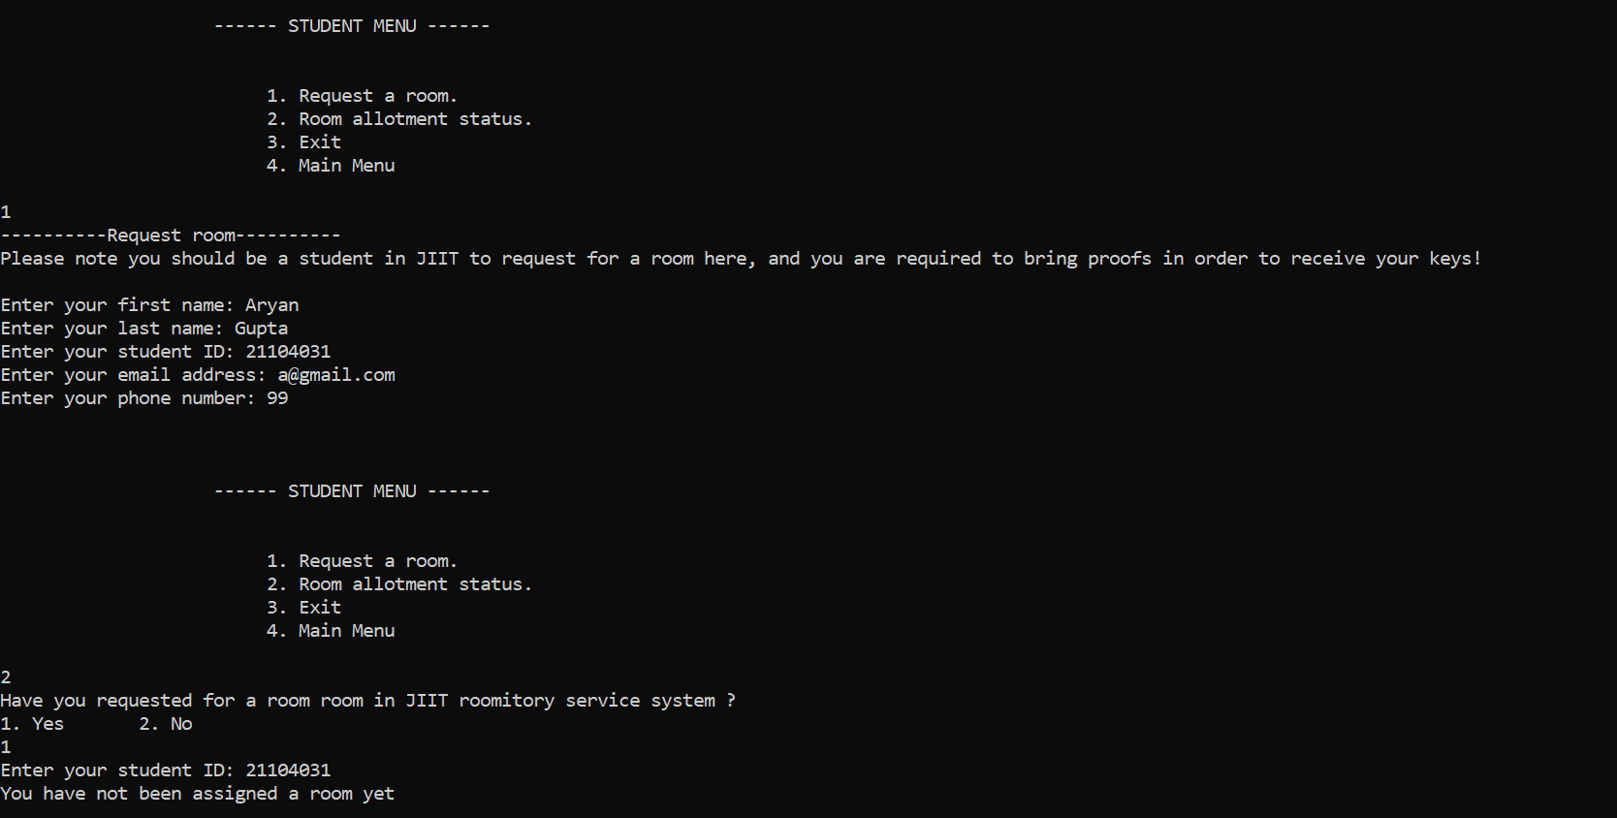 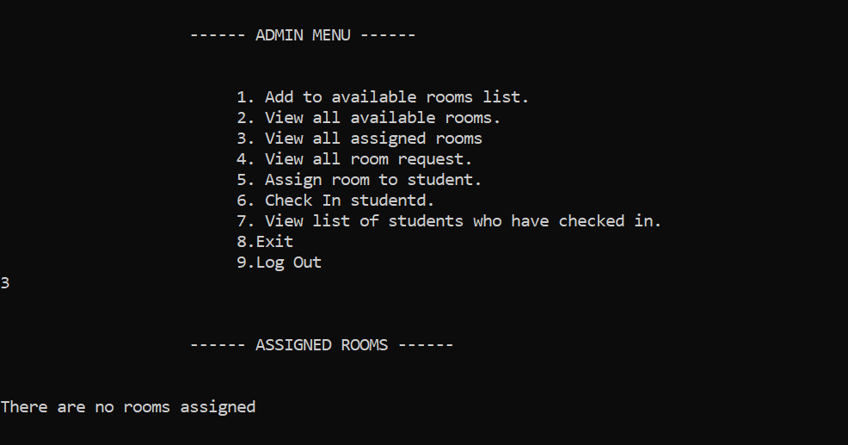

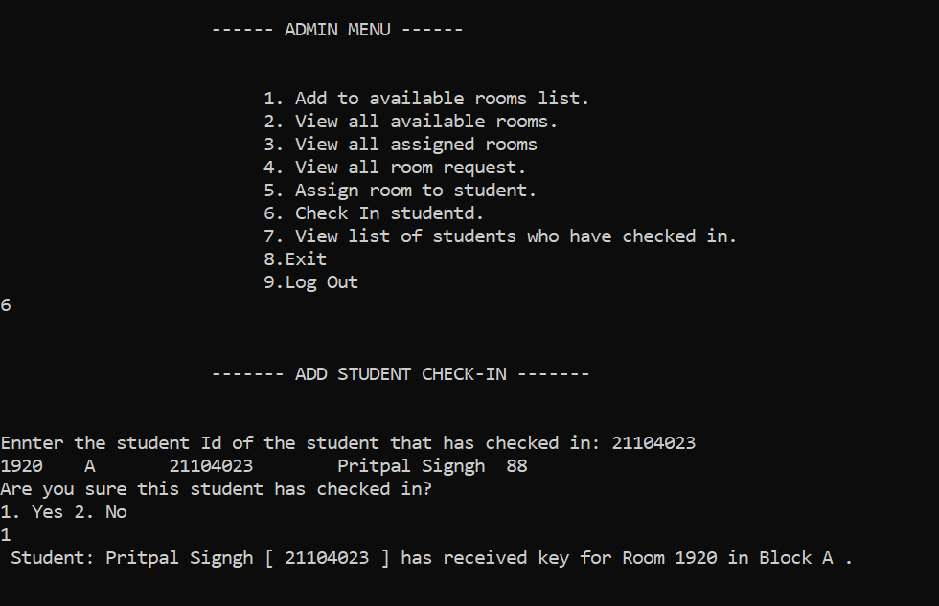

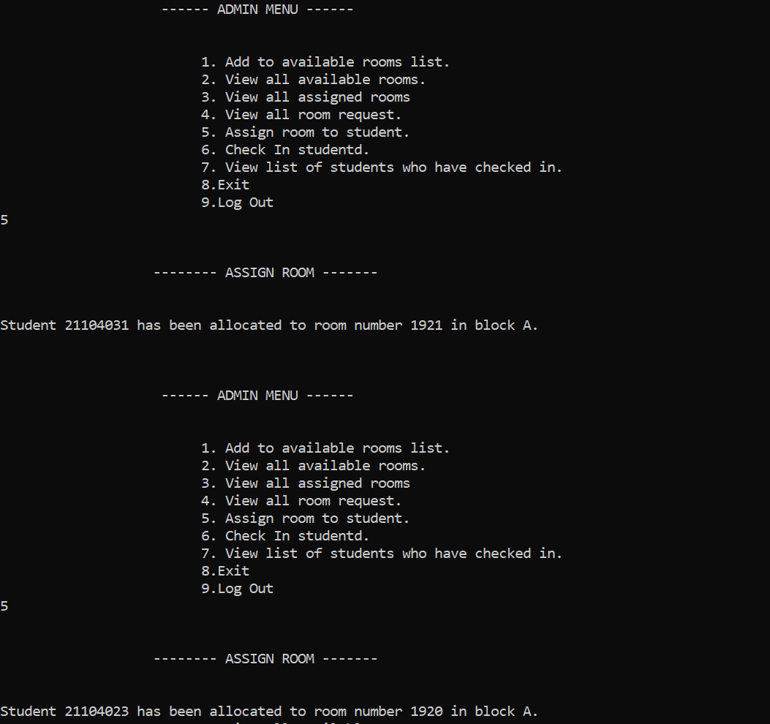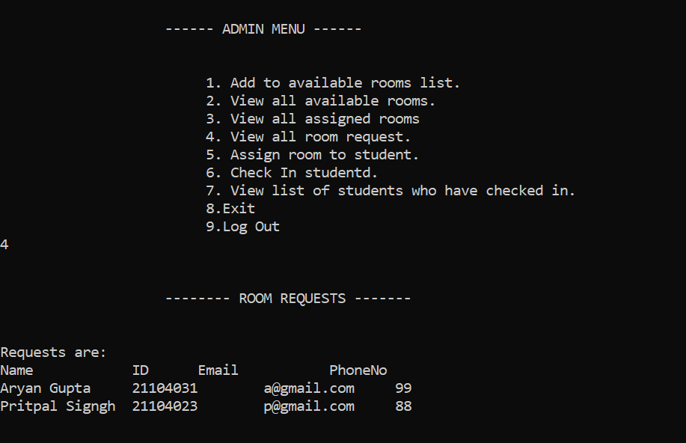

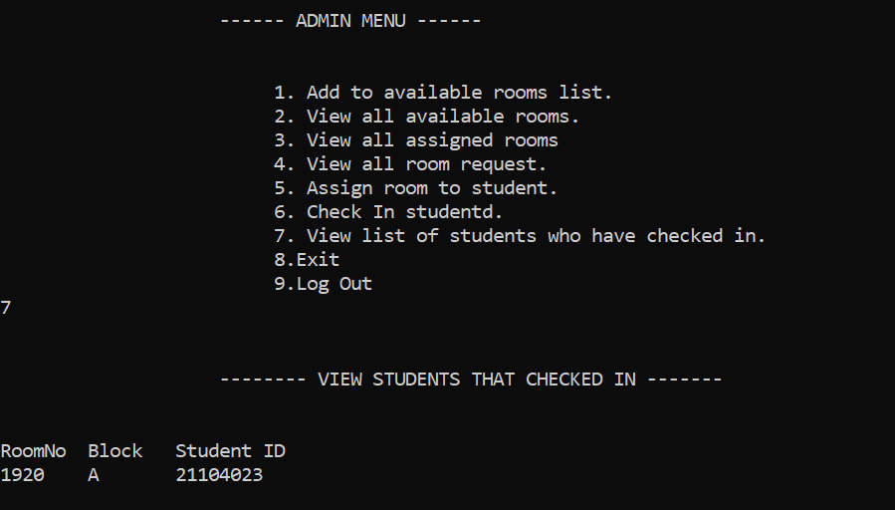

**REFERENCES**

<https://www.geeksforgeeks.org/data-structures/linked-list/>

<https://cplusplus.com/reference/>

<https://www.tutorialspoint.com/data_structures_algorithms/stack_algorithm.htm>

<https://www.tutorialspoint.com/data_structures_algorithms/dsa_queue.htm>

<https://www.javatpoint.com/implementation-of-stack-using-queue>